**Java Map Interface**

The Map interface of the Java collections framework provides the functionality of the map data structure.

It implements the Collection interface.

## Working of Map

In Java, elements of Map are stored in **key/value** pairs. **Keys** are unique values associated with individual **Values**.

A map cannot contain duplicate keys. And, each key is associated with a single value.

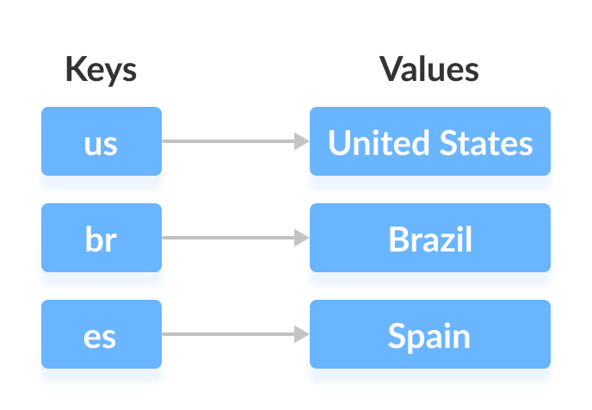

We can access and modify values using the keys associated with them.

In the above diagram, we have values: United States, Brazil, and Spain. And we have corresponding keys: us, br, and es.

Now, we can access those values using their corresponding keys.

**Note:** The Map interface maintains 3 different sets:

* the set of keys
* the set of values
* the set of key/value associations (mapping).

Hence we can access keys, values, and associations individually.

## Classes that implement Map

Since Map is an interface, we cannot create objects from it.

In order to use functionalities of the Map interface, we can use these classes:

* HashMap
* EnumMap
* LinkedHashMap
* WeakHashMap
* TreeMap

These classes are defined in the collections framework and implement the Map interface.

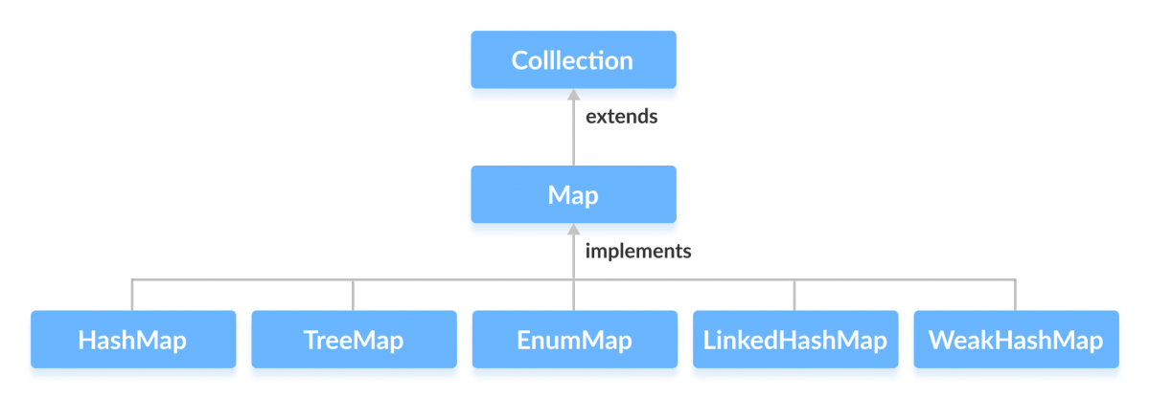

## Interfaces that extend Map

The Map interface is also extended by these subinterfaces:

* SortedMap
* NavigableMap
* ConcurrentMap

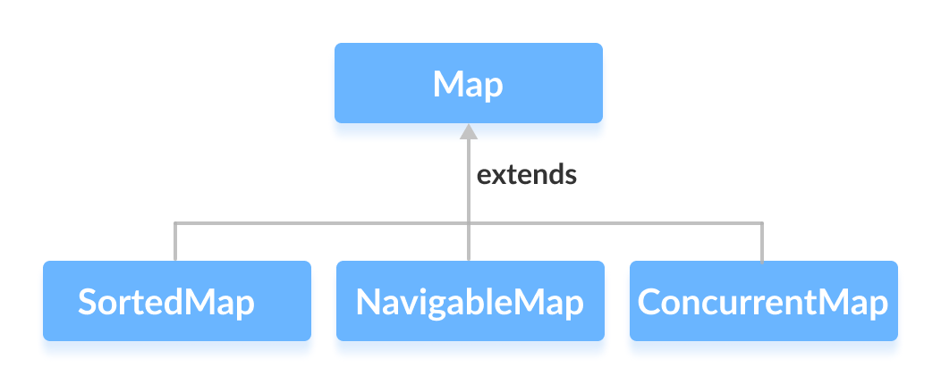

## How to use Map?

In Java, we must import the java.util.Map package in order to use Map. Once we import the package, here's how we can create a map.

// Map implementation using HashMap

Map<Key, Value> numbers = new HashMap<>();

In the above code, we have created a Map named numbers. We have used the HashMap class to implement the Map interface.

Here,

* Key - a unique identifier used to associate each element (value) in a map
* Value - elements associated by keys in a map

## Methods of Map

The Map interface includes all the methods of the Collection interface. It is because Collection is a superinterface of Map.

Besides methods available in the Collection interface, the Map interface also includes the following methods:

* **put(K, V)** - Inserts the association of a key K and a value V into the map. If the key is already present, the new value replaces the old value.
* **putAll()** - Inserts all the entries from the specified map to this map.
* **putIfAbsent(K, V)** - Inserts the association if the key K is not already associated with the value V.
* **get(K)** - Returns the value associated with the specified key K. If the key is not found, it returns null.
* **getOrDefault(K, defaultValue)** - Returns the value associated with the specified key K. If the key is not found, it returns the defaultValue.
* **containsKey(K)** - Checks if the specified key K is present in the map or not.
* **containsValue(V)** - Checks if the specified value V is present in the map or not.
* **replace(K, V)** - Replace the value of the key K with the new specified value V.
* **replace(K, oldValue, newValue)** - Replaces the value of the key K with the new value newValue only if the key K is associated with the value oldValue.
* **remove(K)** - Removes the entry from the map represented by the key K.
* **remove(K, V)** - Removes the entry from the map that has key K associated with value V.
* **keySet()** - Returns a set of all the keys present in a map.
* **values()** - Returns a set of all the values present in a map.
* **entrySet()** - Returns a set of all the key/value mapping present in a map.

## Implementation of the Map Interface

**1. Implementing HashMap Class**

import java.util.Map;

import java.util.HashMap;

class Main {

public static void main(String[] args) {

// Creating a map using the HashMap

Map<String, Integer> numbers = new HashMap<>();

// Insert elements to the map

numbers.put("One", 1);

numbers.put("Two", 2);

System.out.println("Map: " + numbers);

// Access keys of the map

System.out.println("Keys: " + numbers.keySet());

// Access values of the map

System.out.println("Values: " + numbers.values());

// Access entries of the map

System.out.println("Entries: " + numbers.entrySet());

// Remove Elements from the map

int value = numbers.remove("Two");

System.out.println("Removed Value: " + value);

}

}

**Output**

Map: {One=1, Two=2}

Keys: [One, Two]

Values: [1, 2]

Entries: [One=1, Two=2]

Removed Value: 2

To learn more about HashMap, visit Java HashMap.

**2. Implementing TreeMap Class**

import java.util.Map;

import java.util.TreeMap;

class Main {

public static void main(String[] args) {

// Creating Map using TreeMap

Map<String, Integer> values = new TreeMap<>();

// Insert elements to map

values.put("Second", 2);

values.put("First", 1);

System.out.println("Map using TreeMap: " + values);

// Replacing the values

values.replace("First", 11);

values.replace("Second", 22);

System.out.println("New Map: " + values);

// Remove elements from the map

int removedValue = values.remove("First");

System.out.println("Removed Value: " + removedValue);

}

}

**Output**

Map using TreeMap: {First=1, Second=2}

New Map: {First=11, Second=22}

Removed Value: 11